**Graphing and Writing Equations of Lines**

Chapter 5A

Practice Assignments

**Intermediate Algebra**

**Name: _________________________________ Hr: _____**

**Concept 1: Graph Lines with a Table by Plugging in Points**

2

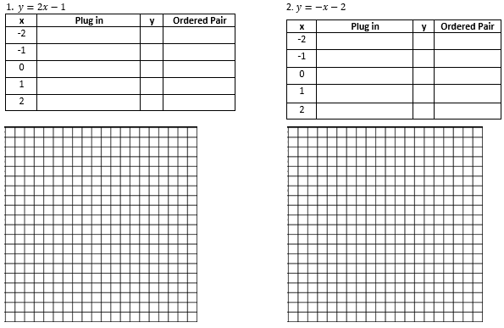

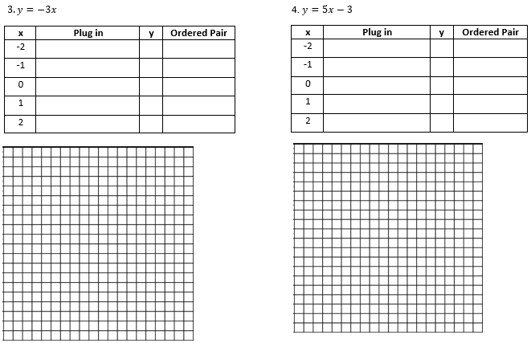

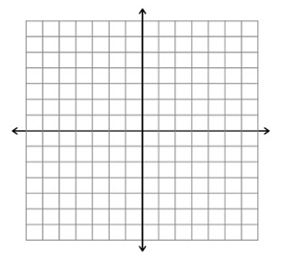







**Concept 2: Verifying that a point “lies on a line” or is a “solution to the equation”.**

3

5. 6.

7. 8.

9. 10.

11. 12.

**Concept 3: Identifying parts of a line (slope and y-intercept) and putting it into slope intercept form.**

4

Write the slope-intercept form of the equation of each line given the slope and y-intercept.

13. 14.

15. 16.

17. 18.

19. 20.

**Concept 4: Write the slope-intercept form of the equation of the line through the given point with the given slope. Graph your answer on the graph.**

5

21. 22.





Equation:_______________

Equation:_______________

23. 24.

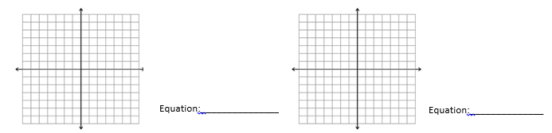

25. 26.



27. 28.



**Concept 5: Write the slope-intercept form of the equation of the line through the given points. Graph your answer on the graph.**

6

29. 30.

Find *m* (use slope formula or use graph): Find *m* (use slope formula or use graph):







31. 32.







Next page for last two problems.

33. 34.

7







**PRACTICE TEST 5A**

8

**Concept 1:**

**Fill in the table and use the ordered pairs to sketch the graph of each line on the graph provided.**

1. 2.

|  |  |  |  |
| --- | --- | --- | --- |
| **x** | **Plug in x** | **y** | **Ordered Pair** |
| -2 |  |  |  |
| -1 |  |  |  |
| 0 |  |  |  |
| 1 |  |  |  |
| 2 |  |  |  |

|  |  |  |  |
| --- | --- | --- | --- |
| **x** | **Plug in x** | **y** | **Ordered Pair** |
| -2 |  |  |  |
| -1 |  |  |  |
| 0 |  |  |  |
| 1 |  |  |  |
| 2 |  |  |  |





**Use the given slope and y-intercept (write as an ordered pair) to sketch the graph of each line on the graph provided.**

3. 4.





**Concept 2: Does the point lie on the line (yes or no)? Must show calculations to verify your answer.**

5. 6. 7. 8.

**Concept 3: Write the slope-intercept form of the equation of each line give the slope and the y-intercept.**

9. 10.

11. 12.

**Concept 4: Write the slope-intercept form of the equation of the line through the given point with the given slope. Graph your answer on the graph provided.**

9

13. 14.



**Concept 5: Write the slope-intercept form of the equation of the line through the given points. Graph your answer on the graph provided.**

15. 14.

