**CHAPTER 9 PRACTICE TEST C1-3**

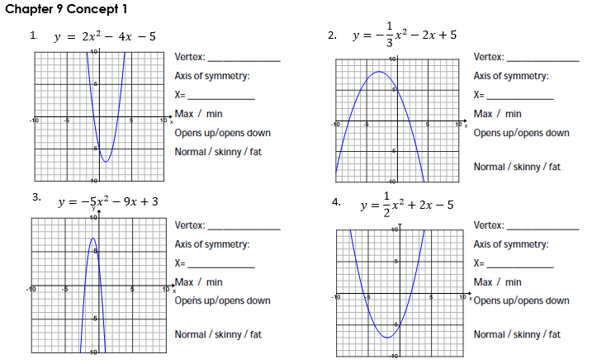



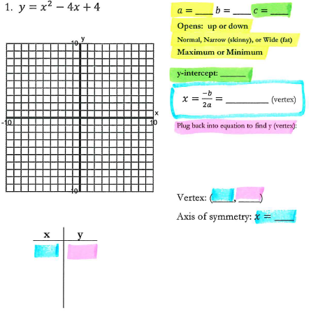

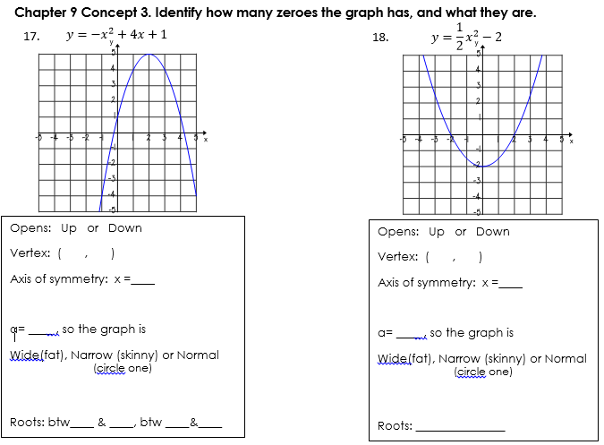



Opens: Up or Down

Vertex: ( , )

Axis of symmetry: x =____

a= ____ , so the graph is

Wide(fat), Narrow (skinny) or Normal

(circle one)

Roots:

$$y=-\frac{1}{3}x^{2}-x+6$$

 _______________

Opens: Up or Down

Vertex: ( , )

Axis of symmetry: x =____

a= ____ , so the graph is

Wide(fat), Narrow (skinny) or Normal

(circle one)

Roots: _______________

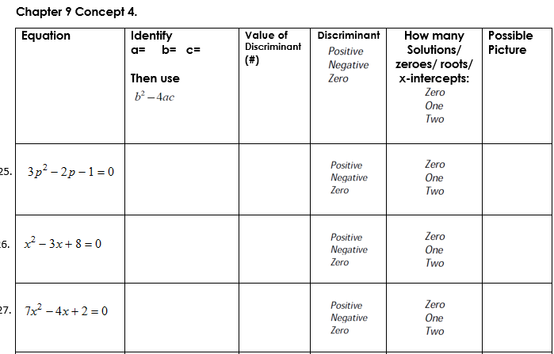

11.

10.

9.

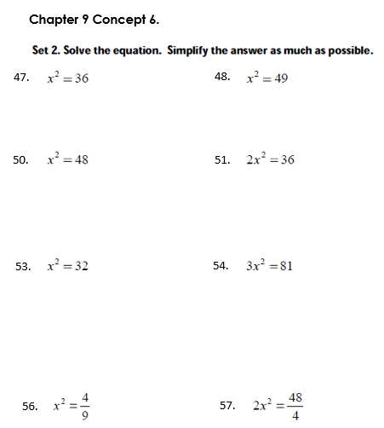

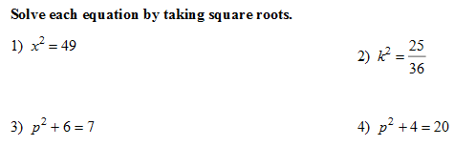

15.

14.

13.

12.

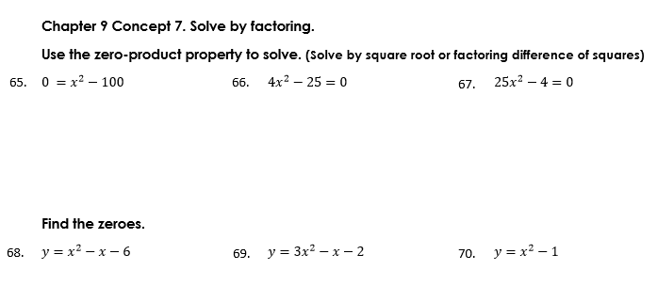

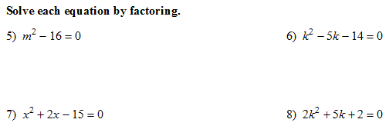

19.

18.

17.

16.



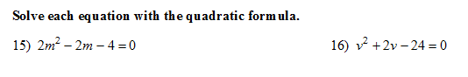

a= _____

b= _____

c= _____

a= _____

b= _____

c= _____

21.

20.